**Presenter I:** Good morning, dear friends. We’re pleased to see you at our party. Today we’ll speak about Ukraine, its geographical position, its people and traditions, about cities and towns of Ukraine. The motto of our party : ”He who loves not his Motherland can love nothing” (G.Byron)

**Presenter II:** We live in Ukraine and I hope you love your native land and you are patriots of your Motherland. It doesn’t matter to what country we travel, what exciting and interesting places we see there – our Mot6herland, the place where you were born and live is the best for you and sooner or later you come back here. So, let’s start our party “I love Ukraine”. We wish you good luck!

**Presenter I:** We‘ve got three teams: 7A form – TEAM OF TRADITIONS, 7B TEAM OF WONDERS, 7 V form – TEAM OF HEROES. You are welcome!

**Presenter II:** Now let’s see the beauty of our Motherland. (Video)

**Presenter I:** What do we know about Ukraine? So now – team presentations.

**Presenter II:** So great you are! Well done!

**Presenter I:** The next task of our quiz is “Say if the statements are true or false”. Team of Traditions will start with the statements. Good luck!

(Task on board)

1. Ukraine is the largest country in Europe. F (one of the biggest)
2. The Ukrainian flag has got three stripes on it. F (two)
3. The other symbol of Ukraine is chestnut tree. F ( it’s the symbol of Kyiv)
4. The Dnipro is the longest river in Ukraine. T

**Presenter II:** Statements for the Team of Wonders. Be attentive!

1. Ukrainian people are proud of their Motherland. T
2. Kyiv is a very modern city. F (the oldest)
3. The 28th of June is the Independence Day. F (24th of August)
4. Ukraine borders on Poland, Slovakia, Romania and Kazakhstan. F (Russia, Belorus`)

**Presenter I:** The team ofHeroes will finish this task. Please statements for you.

1. Taras Shevchenko was born in 1812. F
2. The founder of the Zaporizhian Sich was Dmytro “Baida” Vyshnevetsky. T
3. The author of “Eneid” was Lesia Ukrainka. F (Ivan Franko)
4. The cities of Kyiv, Lviv, Kharkiv and Donetsk hosted the 2012 Euro Football Championship. T

**Presenter II:** So clever you are! We see that you know our country rather well.

**Presenter I:** The next task is – Fill in the gaps with the words given below:

*banks, wash, longest, rivers, European, population, devoted, snowball-tree, mineral resources, capital, mountains, interest, Christmas*

1. Ukraine is a _________ country.
2. The __________ of our Motherland is Kyiv.
3. It is on the __________ of the Dnipro River.
4. The Black Sea and the Sea of Azov __________ Ukraine.
5. There are beautiful ___________ in our country: the Carpathian and the Crimean.
6. There are many ___________ in our country: the Dnipro, the Dnister and the Bug.
7. The __________ river is the Dnipro.
8. The __________ of Ukraine is 46 million people.
9. Ukraine is rich in __________ .
10. People sing songs about a ___________ and plant it near their houses.
11. There are many places of historical ___________ in Lviv.
12. Ukrainians celebrate __________ on the 7th of January and go to church to praise God.

**Presenter II:** And now music contest. Guess the song about Ukraine or its symbols.

**Presenter I:** Ukrainian language is one of the melodious languages in the world, which is on the third place among Italian and Persian. The task of the teams is – to write down as many adjectives as you know depicting our native language.

* рідна - native квітуча - flowering, blooming
* ніжна - tender,
* мила - cute
* світанкова -
* ясна - clear, fine, definite, distinct, elegant
* чиста - pure, excellent
* колискова - lullaby
* мелодійна - melodious
* дзвінка - clinking, tinkling
* дивна - amazing,
* радісна - joyous, happy, delightful
* співуча - singing, songful
* лагідна - gentle
* жива - vivid, live, alive, living
* казкова - fairy, dreamlike
* класна - cool
* чарівна - charming, magic
* шовкова - silk
* найдорожча - dear
* добра - good, nice
* власна - own
* мудра - smart, wise, wonderful, splendid,
* сонячна - sunny, shiny
* прекрасна - beautiful
* солов їна - nightingale

**Presenter II:** We are real Ukrainians and patriots of Ukraine. We’ve prepared a musical gift for you. (Pupils dance).

**Presenter I:** The next part of our show is: Match the first part of the phrase to the second one to make up a proverb. Please, give the Ukrainian equivalents of these proverbs.

|  |  |
| --- | --- |
| 1) East or West  2) Every bird  3) An Englishman’s home  4) There is no place  5) Home is where  6) To every bird | 1. likes its nest. 2. like home. 3. the heart is. 4. its own nest is beautiful. 5. home is best. 6. is his castle. |

**Presenter II:** Language is a living organism. Different languages interact with each other: one language elements get into another system, etc. This phenomenon is called interference. As a result, in the Ukrainian lexicology the layer of loanwords was formed. So, the following task: replace the words of foreign origin with the English equivalents.

степлер ______________________ мітинг _______________________

офіс _________________________ гардероб _____________________

фотографія ____________________ кліп _________________________

вертоліт ______________________ креатив ______________________

кур’єр ________________________ аромат _______________________

резонанс ______________________ шоу _________________________

**Presenter I:** (shows the banknotes of UAH) Do you know well Ukrainian money?

Try to answer: “Whose portrait is it?”

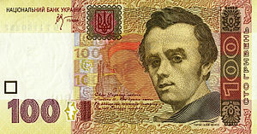 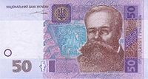

Taras Shevchenko Myhailo Hrushevsky

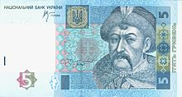 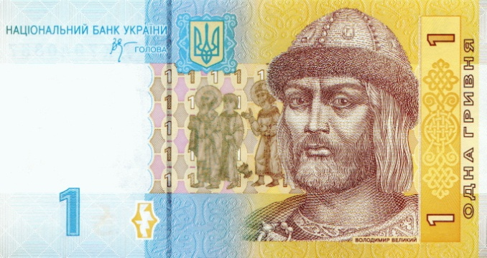

Bohdan Khmelnytsky Volodymyr the Great (Velykyi)

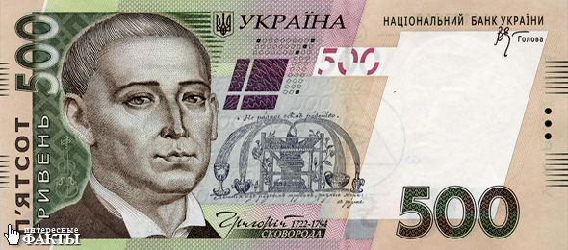 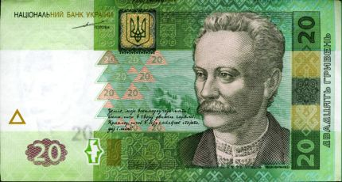

Hryhoriy Skovoroda Ivan Franko

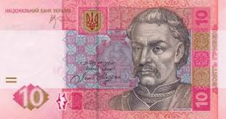 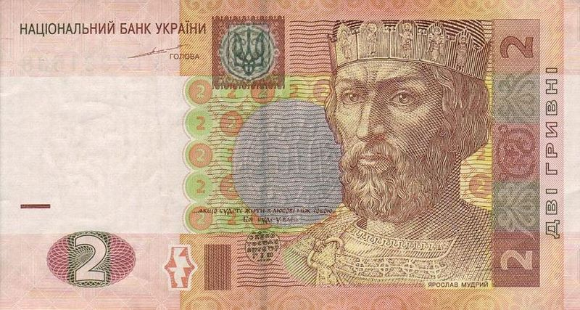

Ivan Mazepa Yaroslav the Wise

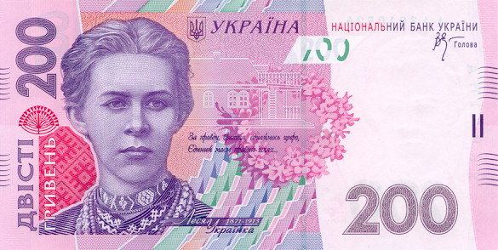

Lesia Ukrainka

**Presenter II:** I am sure that you know the Ukrainian national holidays and festivals. Match the names of the holidays and their dates.

|  |  |  |
| --- | --- | --- |
| 1 January |  | 1) Independence Day |
| 7 January |  | 2) Mother’s Day |
| 2nd Sunday of May |  | 3) Women’s Day |
| 24 August |  | 4)Day of Knowledge |
| April - May |  | 5)St. Nicolas’ Day |
| 1-2 May |  | 6) New Year’s Day |
| 1 June |  | 7) Father’s Day |
| 3rd Sunday of June |  | 8) Easter |
| 28 June |  | 9) Christmas |
| 1 September |  | 10) Day of Spring and Labour |
| 8 March |  | 11) Constitution Day |
| 19 December |  | 12) Day of Protection of Children |

**Presenter I:** Now the contest is “Magic Photobox”. We’ll check if you know the places of interest and symbols of Ukraine. (on board)

**Presenter II:** Nice of you. That was our last task for today.

**Presenter I:** While the jury is counting the smiles and choosing the winner we’ll have a pleasure to admire this wonderful song. (Zlata Ognevich “Pray for Ukraine)

**Presenter II:** Thank you for your attention. The competition is over. Team of … is the winner. Congratulations!

Poem of 7B form

“My native land”

My native land,

The land of wonders,

Of autumn rains

And summer thunders.

The greenest hills

And magic lakes,

The tender breeze,

Romantic dales.

Amazing land –

My dear Ukraine.

Poem of 7V form

“Ukraine”

Blue sky and yellow field of grain

Is on the flag of my Ukraine.

Its emblem speaks to all the world

With FREEDOM – such a lovely word.

Bread–salt will give to a friendly guest

Ukrainian people without request.

They work and sing the song of praise

To God who’s able from ash to raise.

Ukraine rejoices in the Lord

Reviving from His mighty Word.

Forever lives who’s born again

Long live and pray, my land Ukraine!

Team of _____________

**Fill in the gaps with the words given below:**

*banks, wash, longest, rivers, European, population, devoted, snowball-tree, mineral resources, capital, mountains, interest, Christmas*

1. Ukraine is a _________ country.
2. The __________ of our Motherland is Kyiv.
3. It is on the __________ of the Dnipro River.
4. The Black Sea and the Sea of Azov __________ Ukraine.
5. There are beautiful ___________ in our country: the Carpathian and the Crimean.
6. There are many ___________ in our country: the Dnipro, the Dnister and the Bug.
7. The __________ river is the Dnipro.
8. The __________ of Ukraine is 46 million people.
9. Ukraine is rich in __________ .
10. People sing songs about a ___________ and plant it near their houses.
11. There are many places of historical ___________ in Lviv.
12. Ukrainians celebrate __________ on the 7th of January and go to church to praise God.

Team of _______________

**Fill in the gaps with the words given below:**

*banks, wash, longest, rivers, European, population, devoted, snowball-tree, mineral resources, capital, mountains, interest, Christmas*

1. Ukraine is a _________ country.
2. The __________ of our Motherland is Kyiv.
3. It is on the __________ of the Dnipro River.
4. The Black Sea and the Sea of Azov __________ Ukraine.
5. There are beautiful ___________ in our country: the Carpathian and the Crimean.
6. There are many ___________ in our country: the Dnipro, the Dnister and the Bug.
7. The __________ river is the Dnipro.
8. The __________ of Ukraine is 46 million people.
9. Ukraine is rich in __________ .
10. People sing songs about a ___________ and plant it near their houses.
11. There are many places of historical ___________ in Lviv.
12. Ukrainians celebrate __________ on the 7th of January and go to church to praise God.

Team of ________________

**Replace the actual words of foreign origin with the English equivalents.**

степлер ___________________ мітинг _______________________

офіс _________________________ гардероб _____________________

фотографія ____________________ кліп _________________________

вертоліт ______________________ креатив ______________________

кур’єр ________________________ аромат _______________________

резонанс ______________________ шоу _________________________

Team of ________________

**Replace the actual words of foreign origin with the English equivalents.**

степлер ___________________ мітинг _______________________

офіс _________________________ гардероб _____________________

фотографія ____________________ кліп _________________________

вертоліт ______________________ креатив ______________________

кур’єр ________________________ аромат _______________________

резонанс ______________________ шоу _________________________

Team of ________________

**Replace the actual words of foreign origin with the English equivalents.**

степлер ___________________ мітинг _______________________

офіс _________________________ гардероб _____________________

фотографія ____________________ кліп _________________________

вертоліт ______________________ креатив ______________________

кур’єр ________________________ аромат _______________________

резонанс ______________________ шоу _________________________

Team of _________________

**Match the names of the holidays and their dates.**

|  |  |  |
| --- | --- | --- |
| 1 January |  | 1) Independence Day |
| 7 January |  | 2) Mother’s Day |
| 2nd Sunday of May |  | 3) Women’s Day |
| 24 August |  | 4)Day of Knowledge |
| April - May |  | 5)St. Nicolas’ Day |
| 1-2 May |  | 6) New Year’s Day |
| 1 June |  | 7) Father’s Day |
| 3rd Sunday of June |  | 8) Easter |
| 28 June |  | 9) Christmas |
| 1 September |  | 10) Day of Spring and Labour |
| 8 March |  | 11) Constitution Day |
| 19 December |  | 12) Day of Protection of Children |

Team of _________________

**Match the names of the holidays and their dates.**

|  |  |  |
| --- | --- | --- |
| 1 January |  | 1) Independence Day |
| 7 January |  | 2) Mother’s Day |
| 2nd Sunday of May |  | 3) Women’s Day |
| 24 August |  | 4)Day of Knowledge |
| April - May |  | 5)St. Nicolas’ Day |
| 1-2 May |  | 6) New Year’s Day |
| 1 June |  | 7) Father’s Day |
| 3rd Sunday of June |  | 8) Easter |
| 28 June |  | 9) Christmas |
| 1 September |  | 10) Day of Spring and Labour |
| 8 March |  | 11) Constitution Day |
| 19 December |  | 12) Day of Protection of Children |

Team of ________________

**Match the first part of the phrase to the second one to make up a proverb. Give the Ukrainian equivalents of these proverbs.**

|  |  |
| --- | --- |
| 1) East or West  2) Every bird  3) An Englishman’s home  4) There is no place  5) Home is where  6) To every bird | 1. likes its nest. 2. like home. 3. the heart is. 4. its own nest is beautiful. 5. home is best. 6. is his castle. |

________________________________________________________________

________________________________________________________________

________________________________________________________________

________________________________________________________________

________________________________________________________________

Team of ________________

**Match the first part of the phrase to the second one to make up a proverb. Give the Ukrainian equivalents of these proverbs.**

|  |  |
| --- | --- |
| 1) East or West  2) Every bird  3) An Englishman’s home  4) There is no place  5) Home is where  6) To every bird | 1. likes its nest. 2. like home. 3. the heart is. 4. its own nest is beautiful. 5. home is best. 6. is his castle. |

________________________________________________________________

________________________________________________________________

________________________________________________________________

________________________________________________________________

________________________________________________________________

Team of _________________

**Write as many adjectives as you know depicting our native language.**

Answer Keys

**True or false?**

(Task on board)

**Presenter I:** Team of Traditions will start with the statements. Good luck!

1. Ukraine is the largest country in Europe. F (one of the biggest)
2. The Ukrainian flag has got three stripes on it. F (two)
3. The other symbol of Ukraine is chestnut tree. F ( it’s the symbol of Kyiv)
4. The Dnipro is the longest river in Ukraine. T

**Presenter II:** Statements for the Team of Wonders. Be attentive!

1. Ukrainian people are proud of their Motherland. T
2. Kyiv is a very modern city. F (the oldest)
3. The 28th of June is the Independence Day. F (24th of August)
4. Ukraine borders on Poland, Slovakia, Romania and Kazakhstan. F (Russia, Belorus`)

**Presenter I:** The Team ofHeroes will finish this task. Please statements for you.

1. Taras Shevchenko was born in 1812. F
2. The founder of the Zaporizhian Sich was Dmytro “Baida” Vyshnevetsky. T
3. The author of “Eneid” was Lesia Ukrainka. F (Ivan Franko)
4. The cities of Kyiv, Lviv, Kharkiv and Donetsk hosted the 2012 Euro Football Championship. T

**Fill in the gaps with the words given below:** (task on green cards)

*banks, wash, longest, rivers, European, population, devoted, snowball-tree, mineral resources, capital, mountains, interest, Christmas*

1. Ukraine is a *European* country.
2. The *capital* of our Motherland is Kyiv.
3. It is on the *banks* of the Dnipro River.
4. The Black Sea and the Sea of Azov *wash* Ukraine.
5. There are beautiful *mountains* in our country: the Carpathian and the Crimean.
6. There are many *rivers* in our country: the Dnipro, the Dnister and the Bug.
7. The *longest* river is the Dnipro.
8. The *population* of Ukraine is 46 million people.
9. Ukraine is rich in *mineral resources*.
10. People sing songs about a *snowball-tree* and plant it near their houses.
11. There are many places of historical *interest* in Lviv.
12. Ukrainians celebrate *Christmas* on the 7th of January and go to church to praise God.

(task on cards)

**Match the first part of the phrase to the second one to make up a proverb. Give the Ukrainian equivalents of these proverbs.**

|  |  |
| --- | --- |
| 1) East or West  2) Every bird  3) An Englishman’s home  4) There is no place  5) Home is where  6) To every bird | 1. likes its nest. 2. like home. 3. the heart is. 4. its own nest is beautiful. 5. home is best. 6. is his castle. |

1. e; 2. a; 3. f; 4. b; 5. c; 6. d

(task on cards)

**Replace the actual words of foreign origin with the English equivalents.**

степлер stapler мітинг meeting

офіс office гардероб wardrobe

фотографія photo кліп clip

вертоліт helicopter креатив creative

кур’єр courier аромат aroma

резонанс resonance шоу show

(task on board)

**Do you know well Ukrainian money? Try to answer: “Whose portrait is it?”**

1 UAH - Volodymyr the Great

2 UAH - Yaroslav the Wise

5 UAH - Bohdan Khmelnytsky

10 UAH - Ivan Mazepa

20 UAH - Ivan Franko

50 UAH - Myhailo Hrushevsky

100 UAH - Taras Shevchenko

200 UAH - Lesia Ukrainka

500 UAH - Hryhoriy Skovoroda

**Match the names of the holidays and their dates.**

|  |  |  |
| --- | --- | --- |
| 1 January | 6 | 1) Independence Day |
| 7 January | 9 | 2) Mother’s Day |
| 2nd Sunday of May | 2 | 3) Women’s Day |
| 24 August | 1 | 4)Day of Knowledge |
| April - May | 8 | 5)St. Nicolas’ Day |
| 1-2 May | 10 | 6) New Year’s Day |
| 1 June | 12 | 7) Father’s Day |
| 3rd Sunday of June | 7 | 8) Easter |
| 28 June | 11 | 9) Christmas |
| 1 September | 4 | 10) Day of Spring and Labour |
| 8 March | 3 | 11) Constitution Day |
| 19 December | 5 | 12) Day of Protection of Children |

(task on board)

**“Magic Photobox”**